Week 5- Course Project

Wireframe/Storyboard
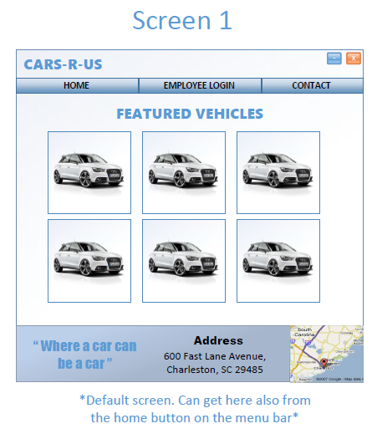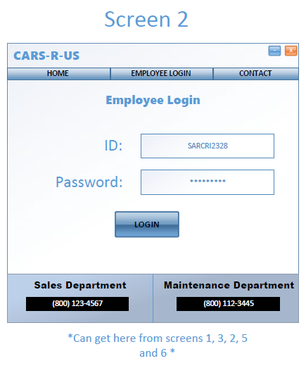
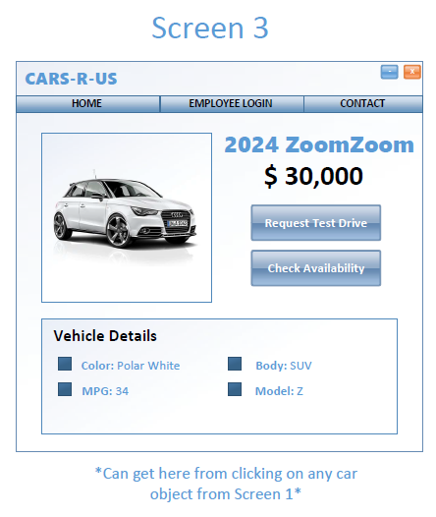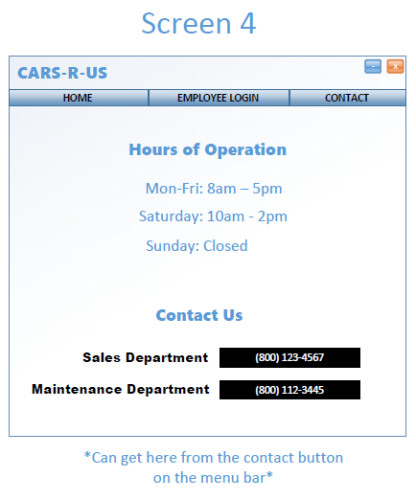
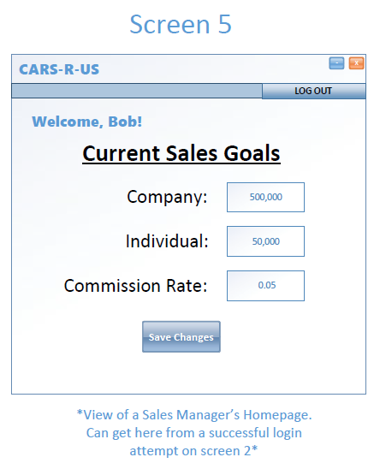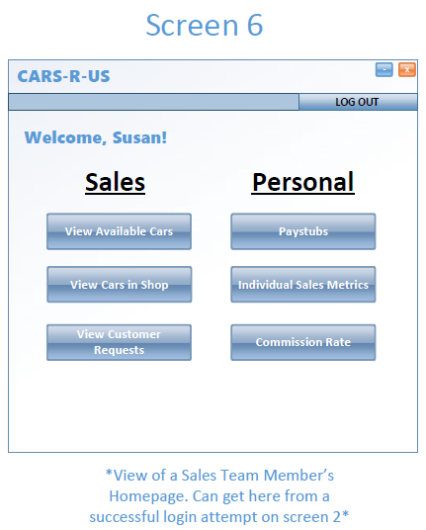

Interactivity Diagram
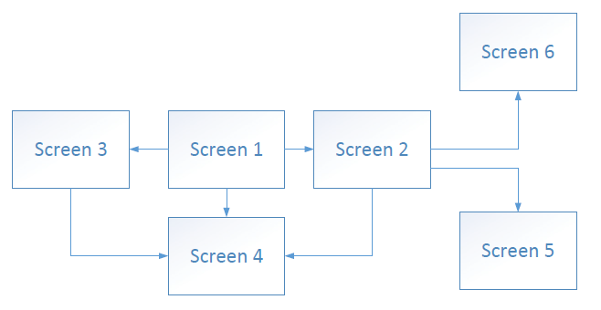

Object Dictionary
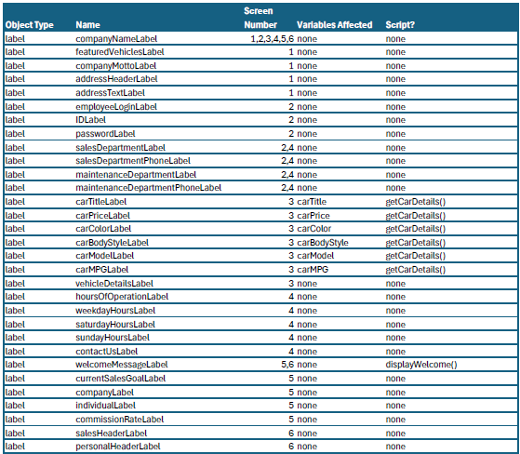
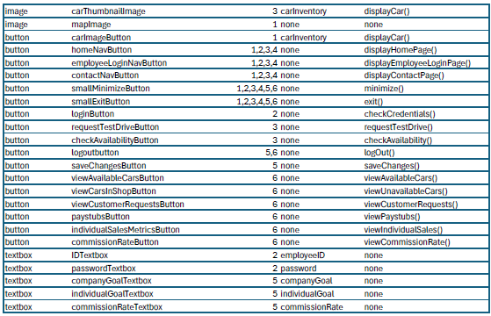

Scripts
//Declarations
String employeeName
String carTitle
String carColor
String carBodyStyle
String carModel
Num carPrice
Num carMPG

public void getCarDetails()
carTitleLabel = carTitle
carPriceLabel = carPrice
carColorLabel = carColor
carBodyStyleLabel = carBodyStyle
carModelLabel = carModel
carMPGLabel = carMPG
return

public static void saveChanges()
commissionRate = commissionRateTextbox.getEntered()
individualGoal = individualGoalTextbox.getEntered()
companyGoal = companyGoalTextbox.getEntered()
return

public static void displayHomePage()
currentScreen.remove()
screen1.display()
return

public static void displayEmployeeLoginPage()
currentScreen.remove()
screen2.display()
return

public static void displayContactPage()
currentScreen.remove()
screen4.display()
return

public static void displayWelcome()
output “Welcome, ” & employeeName & “!”
return

//These would be built-in functions in whichever language I am using
public void exit()
public void minimize()

//Functions that are beyond the scope of this project but would be needed for the app
displayCar()
checkCredentials()
logOut()
viewCustomerRequests()
viewPaystubs()
viewIndividualSales()
viewCommissionRate()
viewAvailableCars()
viewUnavailableCars()
requestTestDrive()
checkAvailability()

